

**Claim Status Tool**

**Version 3.0  
Launch: July 30, 2025**

Revision History

| Date | Version | Description | Author |
| --- | --- | --- | --- |
| 2020 | 1 | Product Guide | Unknown |
| 3/25/2024 | 2 | Product Guide (Tool Modernization) | Jacob Worrell |
| 6/21/2024 | 2.1 | Expanded Claim Phases (Section 4.5) | Jacob Worrell |
| 6/30/2025 | 3.0 | Changes to Pension Claims; screenshot updates to ensure currency with other VA.gov changes | Saliha Ghaffar |

Table of Contents

1. Overview

2. User Access

3. Navigation

3.1 To application from the homepage

3.2 Using main menu navigation

3.3 Using My VA Dashboard

4. Functionality

4.1 Viewing list of all claims

4.2 Viewing and responding to claim requests

4.3 Viewing “Recent Activity” and responding to third-party requests

4.4 Uploading files not related to specific requests

4.5 Viewing the overview timeline

4.51 Disability Compensation Claims Other than Supplemental Claims

4.52 Non-disability claims

5. Major Issues and Error Messages

5.1 File(s) fails to upload when the user attempts to submit evidence

5.2 Application fails to load or times out

## 1. Overview

The Claim Status Tool on VA.gov enables users to check the status of a VA claim, decision review, or appeal for these types of benefits:

* Disability compensation (including claims based on special needs like an automobile or clothing allowance)
* Veteran’s or Survivor’s Pension benefits
* Special monthly compensation (such as Aid and Attendance)
* Dependency and Indemnity Compensation (DIC)
* Burial allowance to help pay for a Veteran’s burial and funeral expenses
* Specially Adapted Housing (SAH) or Special Housing Adaptation (SHA) grant

In addition, claimants can use the Claim Status Tool for:

* Requests to add or remove dependents
* Requests for approval of school attendance for dependent children

## 2. User Access

Users must be signed in to the site and eligible for VA benefits.

## 3. Navigation

Direct URL: <https://va.gov/track-claims/your-claims>

### 3.1 To application from the homepage

To check status claims: Users starting from the homepage can use the link in “Top pages” to “Check your claim, decision review, or appeal status.”

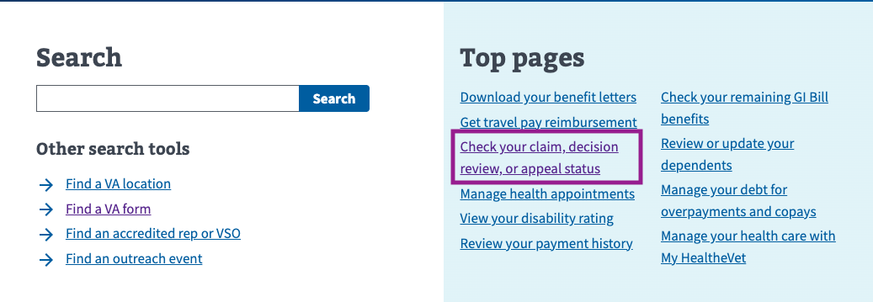

### 3.2 Using main menu navigation

For Disability Claims: Alternatively, users can navigate to the top menu and select VA Benefits and Healthcare > Disability > “Check your claim, decision review, or appeal status.”

For Pension Claims: Alternatively, users can navigate to the top menu and select VA Benefits and Healthcare > Pension > “Check your claim, decision review, or appeal status.”

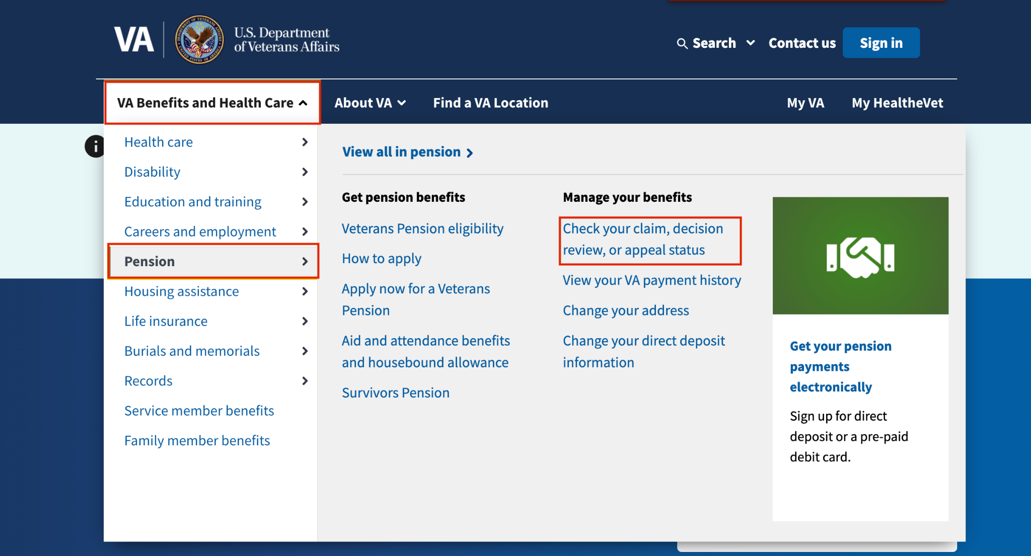

### 3.3 Using My VA Dashboard

Users who sign in from the home page go to VA.gov/my-va/. The top of My VA will display a claim with recent activity, if applicable, along with a link to “Review details.”   
  
To access the CST landing page, users can click “Manage all claims and appeals.”

### 3.4 Authentication from the Claim Status Tool landing page

If a non-verified user (LOA1) attempts to access the CST, a message prompts them to sign in or create an account. If they sign in as a verified user (LOA3), CST will look for their claims.

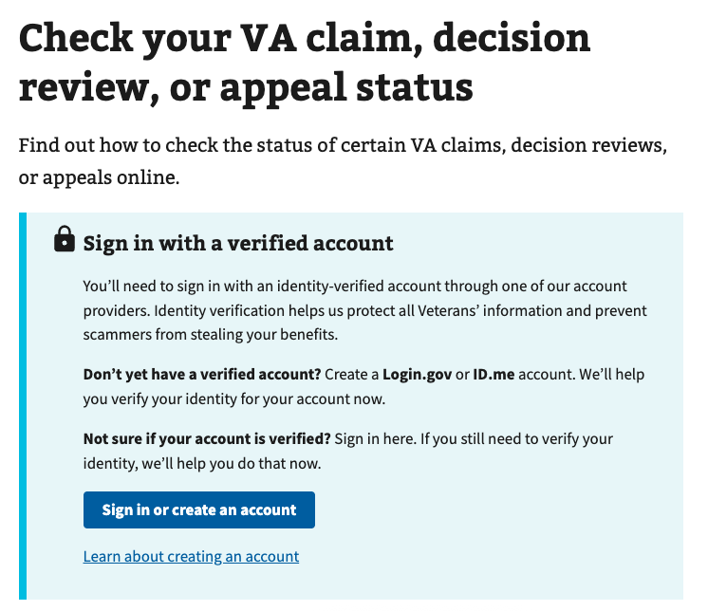

## 4. Functionality

### 4.1 Viewing list of all claims

From the first screen of CST, the user will be able to see a list of their claims. The claim “cards” on this page are displayed so that claims with new evidence requests appear at the top of the stack. Otherwise, claims and appeals are sorted in reverse chronological order.  
  
Claim cards show the following info:

* Type of claim
* Whether the claim is “in progress” or “closed”
* When the claim was received
* Which step the claim is in (for compensation claims)
* The last update date for the claim
* Whether an item requires attention.

For the most common claim type, “compensation,” the next step is usually to click “View details” to review items that need attention.

### 4.2 Viewing and responding to claim requests

In the first “detail” view, a user will see content under the “Status” tab. Above the tab view, the user can view the date the claim was received and the claim conditions.

The “Status” content is divided into two main categories: “What you need to do” and “What we’re doing.” The former provides specific alerts and evidence requests that require the user's attention, while the latter outlines the actions being taken by the VA.

Content in the “What you need to do” section takes the form of individual alerts, often in the form of specific evidence requests. To view more details about a specific evidence request, the user clicks “View Details.”

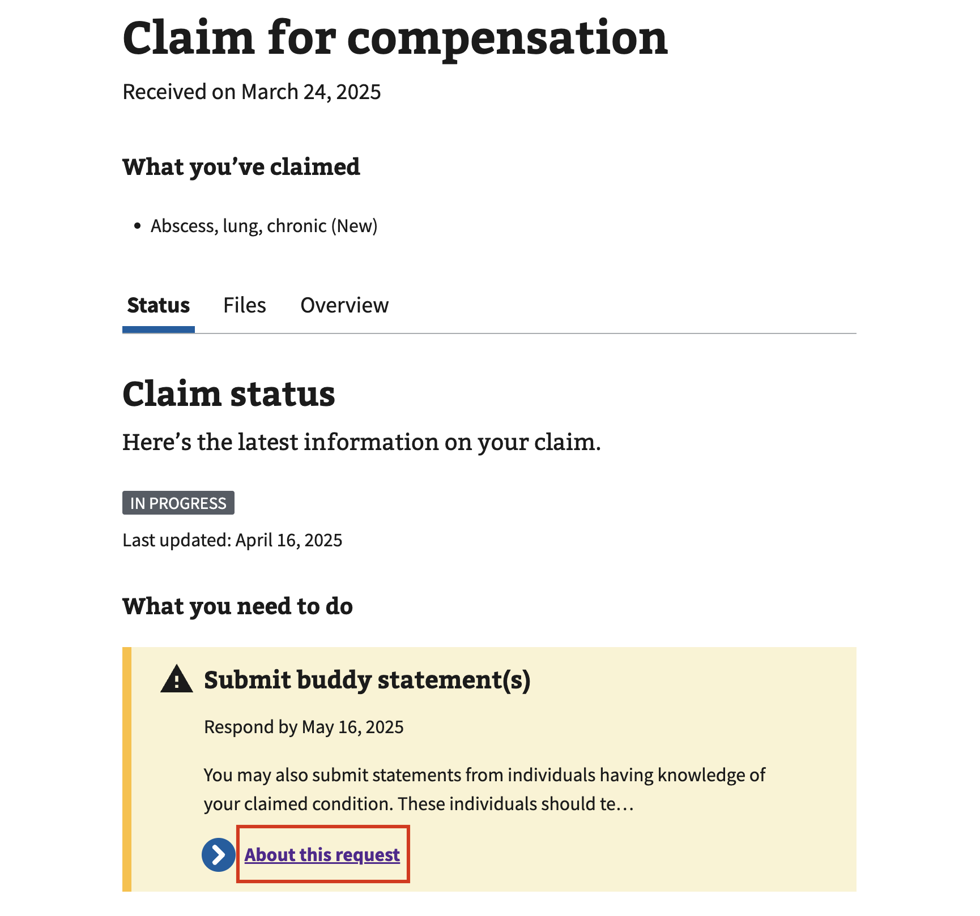

Once the user clicks “View details,” they are presented with a request detail page that provides a more detailed description of the request. Additionally, users will have the ability to upload the specific document requested by clicking “Upload file” and selecting a file from their device.

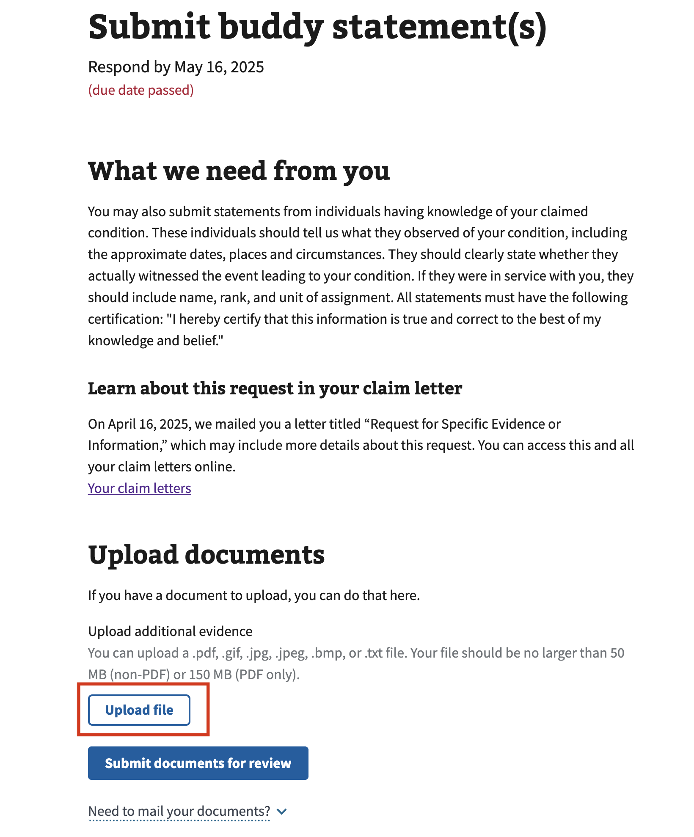

The user can select a file from their device. Once the file is uploaded, they’ll have to use the drop-down and select the file type that most accurately matches the document they uploaded.

After the user uploads their file, they can click “Submit documents for review” to complete the file submission.

### 4.3 Viewing “Recent Activity” and responding to third-party requests

On the “Status tab,” if a user scrolls down the page to the “What we’re doing” section, they will see a list of “Recent Activity.” This activity log displays major claim actions taken, including the time the action was taken and a brief description of each action. If there’s an open third-party request, users will see an alert for it. While they aren’t responsible for meeting this request, if they happen to have the requested information, they can click on “Add it here” within the alert.

The user will then be navigated to a request detail page, as described in Section 4.2. The instructions for uploading documents are similar, but they indicate that the request has been made to someone outside the V, and that the user has the option to upload the document if they have it and would like to.

### 4.4 Uploading files not related to specific requests

At any time, while a claim is under review by the VA, a claimant can upload additional evidence that supports that claim. To do this, they can click the “Files” tab from any claim detail page.

Within the Files tab, under “Additional Evidence,” the Veteran will be shown the same alerts that appear on the “Status” tab, as described in Section 4.2. A Veteran should follow the same steps to respond to these requests from this page.

### 4.5 Viewing the Overview tab

A user can click the “Overview” tab to learn about the claim process. Information under this tab describes the phases of the claim process so Veterans know which phase they’re in and where it sits in the overall process.

Another way to see this timeline is from the “Status” tab in the “What we’re doing section.” There, they will see a condensed description of the current phase of their claim, along with a link labeled “Overview of the process.” Clicking this link will also direct them to the “Overview” tab.

#### 4.51 Disability Compensation and Pension Claims (not including Supplemental Claims)

For initial disability compensation claims, the user will see an eight-phase process graphic and an accordion item for each of the eight phases of the claims journey. Expanding the accordion reveals a description of that step. One accordion item corresponding to the phase the Veteran is currently in will automatically expand. Icons distinguish between steps that are complete, the current step, and steps that are still in progress.

#### 4.52 Other type of claims

Claims other than Disability and Pension will display a more generic “Overview” condensed into 5 steps. Note: We anticipate providing more in-depth information about other claim types in the future.

## 5. Major Issues and Error Messages

### 5.1 File(s) fails to upload when the user attempts to submit evidence

If a particular piece of evidence fails to upload, instead of the confirmation message, the user will be presented with an error alert indicating that an issue has occurred. This alert can occur due to one of the downstream services that provide the information being temporarily unavailable or due to application downtime. When this happens, the user should wait 1-2 hours and then attempt the action again.

In some cases, a user will upload a file, which appears to be successful, but VA.gov will later learn of a failure in delivering the file to another VA system after the user has left the website. When this happens, we send the user an email to notify them of the failure. In these cases, we strongly recommend that the user send the document by postal mail to the address provided in the email or bring the document to a regional office, as we expect the same failure to occur again if they upload the file to VA.gov. In the future, we’ll provide details about such failures in the Claim Status Tool in addition to sending the email.

### 5.2 Application fails to load or times out

There are also some cases in which the entire application itself fails to load or times out. The user may see an error message stating that the application failed, or the application may simply never display the content. In both cases, the user will likely try to refresh the page in their browser, and sometimes that will resolve the issue. Suppose the application fails to load after repeated attempts to reload. In that case, there may be a service issue affecting all of VA.gov or a service upstream to the application, preventing it from loading. In these cases, the user should wait 1-2 hours before trying again.